Republic of the Philippines

National Police Commission

Philippine National Police

**Cavite Police Provincial Office**

**CARMONA MUNICIPAL POLICE STATION**

Brgy Maduya, Carmona, Cavite

***carmonacavitepnp@gmail.com***

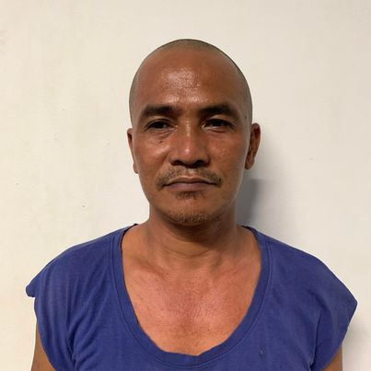

April 5, 2022

**CERTIFICATE OF DETENTION**

**TO WHOM IT MAY CONCERN**

**THIS IS TO CERTIFY** that one **RANDY CARAVANA ALCANSE**, male, 44 years old, born on **April 20, 1977**, married, resident of **B19 L33 Phase 3 Brgy. Milagrosa, Carmona, Cavite** was detained at this office since January 18, 2022 up to present and charged for the crime of **“Sec. 5 and 11 ART II of RA 9165”** with Criminal Case Nr. **CAR-2022-56 & 57,** before the Office of Provincial Prosecutor, Imus, Cavite.

This certification is being issued upon request of interested party for whatever legal purposes it may serve.

Prepared by :

Randy Alcanse, **PSSg Anderson A Videña**

Detainee Custodial Officer